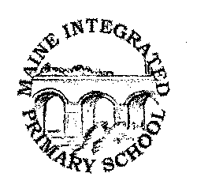 | Maine Integrated Primary School  Building Bridges, Learning Together  Principal: Mrs E Woodin  93 Portglenone Road, Randalstown, BT41 3EH  Tel/Fax 028 944 78766 info@maineips.randalstown.ni.sch.uk
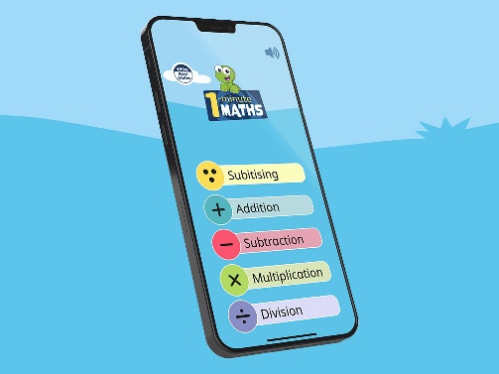

Dear Parent/Guardian

I wanted to share a wonderful maths app that will benefit many of our children at Maine. The app is called ‘The One Minute Maths’ App from White Rose.

This app is free to download on Androids/iPad however you will have to subscribe for use on desktops.

The app helps children build greater number confidence and fluency. It’s all about targeted practice in engaging, one-minute chunks!

How can the app be used?
Children can choose any topic they want from the operations. Then they answer a unique set of questions (different set of questions every time) If they are struggling with a question, they can hit hint button for a helpful clue by showing the question in a different way. When the one minute is up, they'll see a feedback screen telling how they've done.
I hope you find this app useful in helping support your child develop their number confidence and fluency.

Yours sincerely,

A Coey
_________________________________
Mrs A Coey

Numeracy Coordinator

